***NAME : Himanshu Dixit***

***ENROLL NO. : B64178***

***BATCH : B10***

***Software Development Fundamentals – I (15B11CI111)***

***ODD 2021***

***Tutorial Sheet – 4***

**Q1.** Write a C program which reads the values of four variables say- w, x, y and z from the user and evaluates the ratio of (w+y) to (x-z) and prints the result, if (x-z) is not equal to zero.

**Solution:**

#include<math.h>

int main()

{

float w,x,y,z;

float a,b,c;

printf("enter a integer w:");

scanf("%f", &w);

printf("enter a integer x:");

scanf("%f", &x);

printf("enter a integer y:");

scanf("%f", &y);

printf("enter a integer z:");

scanf("%f", &z);

a=w+y;

b=x-z;

c=a/b;

if(c<0)

c=-c;

if(b==0)

printf("invalid input b=0");

else

printf("%.02f",c);

return 0;

}

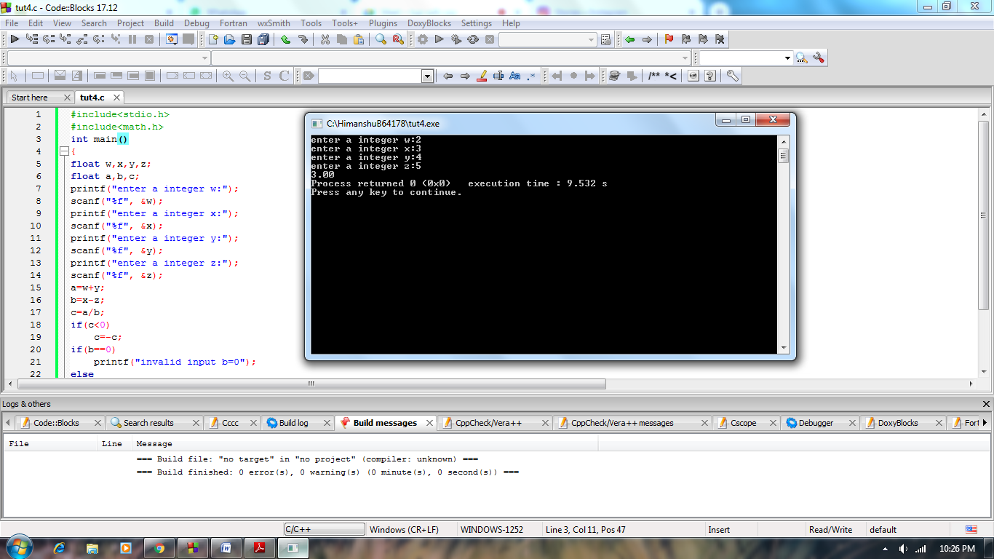

**Q2.** Write a C program that will read the value of x and evaluate the following function y= {1 for x>0 ; 0 for x =0; -1 for x <0 } using:

(a) nested if statements.

(b) else if statements

**Solution:**

**(a)**

#include<stdio.h>

int main()

{

int a;

scanf("%d",&a);

if(a>=0)

{

if(a==0)

printf("y=0");

if(a>0)

printf("y=1");

}

if(a<0)

printf("y=-1");

return 0;

}

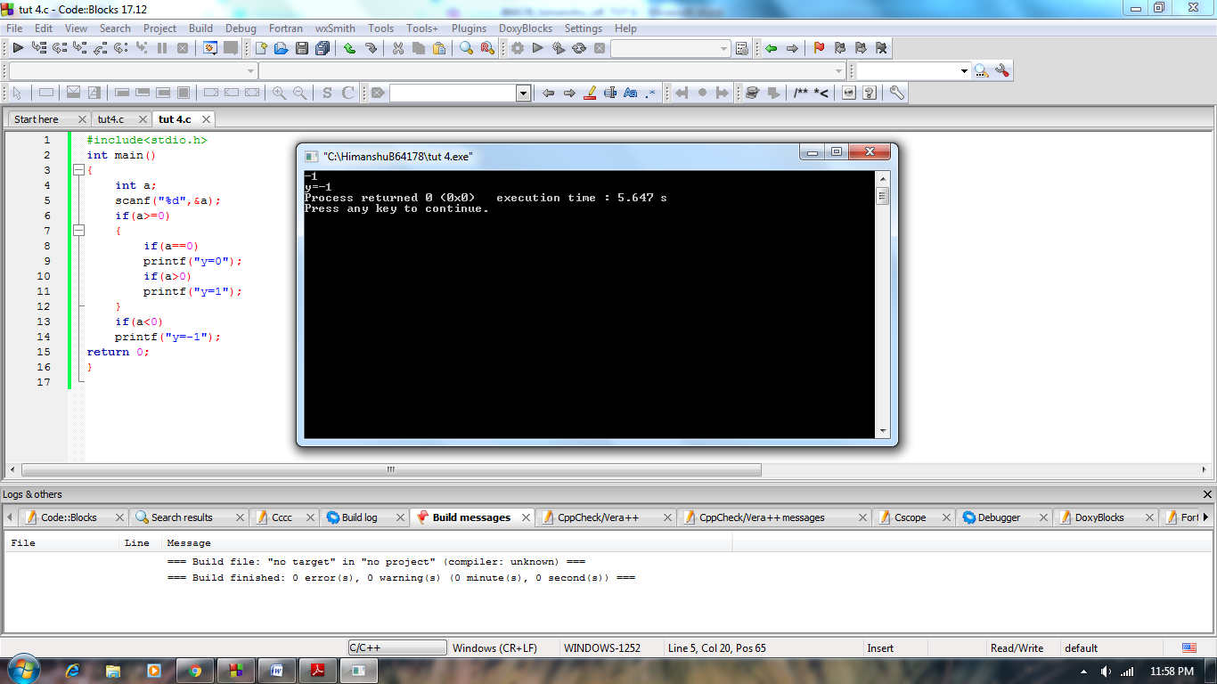

**(b)**

#include<stdio.h>

int main()

{

int a;

scanf("%d",&a);

if(a==0)

printf("y=0");

else if(a>0)

printf("y=1");

else

printf("y=-1");

return 0;

}

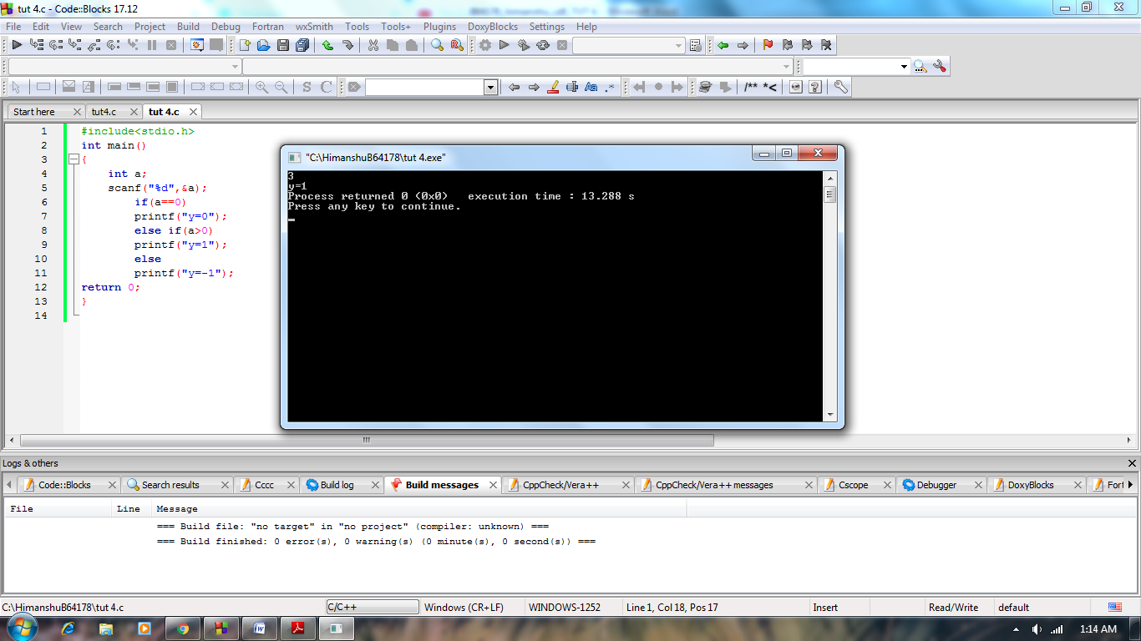

**Q3.** The output of the following segment when executed is:

#include <stdio.h>

void main(){

int a=10, b=5;

if(a>b){

if(b>5)

printf("%d",b);

}

else

printf("%d",a);

}

A. 5

B. 10

C. 510

D. None

**Solution:**

none

**Q4.** The output of the following segment when executed is:

#include <stdio.h>

int main()

{

    int i = 0;

    switch (i)

    {

        case '0': printf("Indian");

                break;

        case '1': printf("Foods");

                break;

        default: printf("IndianFoods");

    }

    return 0;

}

A. Indian

B. Foods

C. IndianFoods

D. None

**Solution:**

IndianFoods

**Q5.** A person going on a trip has taken a car on rent from a car rental shop. An initial rent is fixed of 100 rupees. After that the rental bill is calculated as per the following rules:

For first 50 kms Rs. 50/km

For next 100 kms Rs. 75/km

For next 100 kms Rs. 120/km

For distance above 250 kms Rs. 150/unit

Calculate total car rental cost of the trip by a person using if else in C programming.

**Solution:**

#include<stdio.h>

void main()

{

int distance;

float totcharge;

printf("enter the distance :");

scanf("%d",&distance);

if(distance<=50)

totcharge=50*distance+100;

else if(distance<=150)

totcharge=50*50+100+(distance-50)*75;

else if(distance<=250)

totcharge=75*100+50*50+100+(distance-150)*120;

else

totcharge=120*100+75*100+50*50+100+(distance-250)*150;

printf("%0.2f is the total charges",totcharge);

}

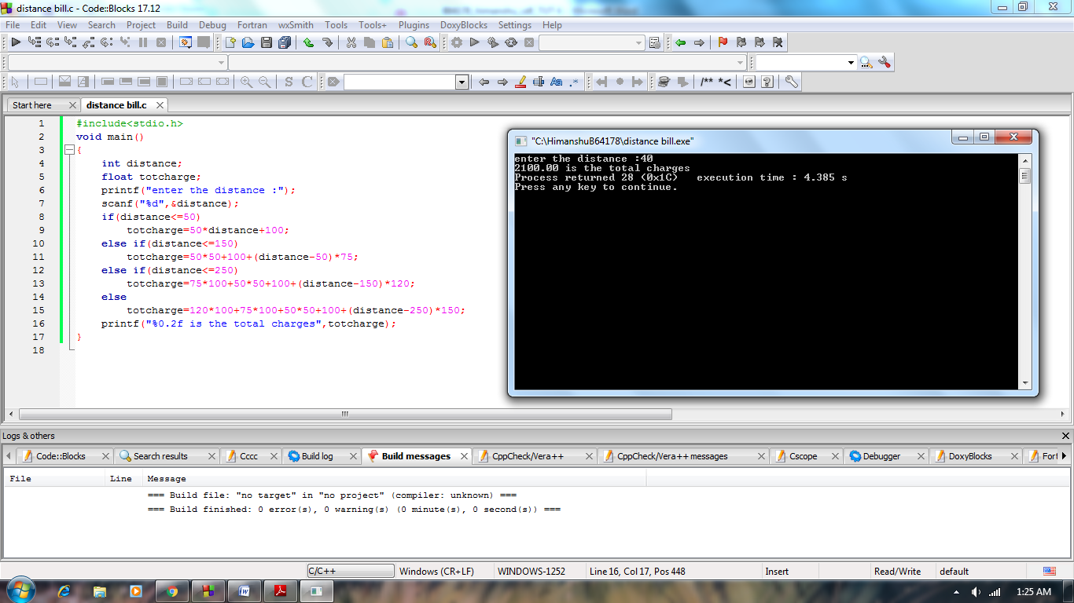

**Find output from Q6-10**

**Q.6** #include"stdio.h"

int main()

{

int i;

if(i=(2,1,0))

printf("World ");

else

printf("Hello ");

printf("%d\n",i);

}

**Solution:**

Hello 0

**Q.7** #include <stdio.h>

int main()

{

    int a=10;

    if(a==10)

    {

        printf("Hello...");

        break;

        printf("Ok");

    }

    else

    {

        printf("Hii");

    }

    return 0;

}

A. Hello...

B. Hello...OK

C. OK

D. Error

**Solution:**

Hello... Ok

**Q.8** #include <stdio.h>

int main()

{

    if( (-100 && 100)||(20 && -20) )

        printf("%s","Condition is true.");

    else

        printf("%s","Condition is false.");

    return 0;

}

**Solution:**

Condition is true.

**Q.9** int main()

{

if(-5)

{

printf("Germany\n");

}

if(5)

{

printf("Texas\n");

}

printf("ZING");

return 0;

}

**Solution:**

Germany

Texas

ZING

**Q.10** #include<stdio.h>

#define L 10

void main()

{

auto a = 10;

switch (a, a*2)

{

case L:

printf("ABC");

break;

case L*2:

printf("XYZ");

break;

case L*3:

printf("PQR");

break;

default:

printf("MNO");

case L*4:

printf("www");

break;

}

}

**Solution:**

XYZ